|  |  |  |  |  |  |  |
| --- | --- | --- | --- | --- | --- | --- |
| |  |  |  |  | | --- | --- | --- | --- | |  | | **MINISTRY OF EDUCATION AND TRAINING** | | | **FPT UNIVERSITY** | | |
| Capstone Project Document |
| Website for maid service |
| |  | | --- | |  |  |  |  | | --- | --- | | **Group 6** | | | **Group member** | Bùi Tiến Tuân – Leader – SE60824  Mạnh Quang Tuyến– Member – SE60890  Trương Hải Đăng – Member – SE60841(dropped out)  Nguyễn Tấn Công – Member – SE60920 | | **Supervisor** | Nguyễn Trọng Tài | | **Ext. Supervisor** | N/A | | **Capstone Project code** | MS-Website | |
| * Ho Chi Minh City, May 2014 – |

Table of Contents

Report 4.System Design Description (SDD) 4

1.1. Design Overview 4

1.2. System Architectural Design 4

1.2.1. Choice of System Architecture 4

1.2.2. Discussion of Alternative Designs 4

1.2.3. Description of System Interface 5

1.3. Component Diagram 5

1.4. Detailed Description of Components 5

1.4.1. Class Diagram 5

1.4.2. Class Diagram Explanation 5

1.5. Sequence Diagram 13

1.5.1. Login 13

1.5.2. Advance Search 13

1.5.3. AddMaid 14

1.5.4. Manage Maid Profile 14

1.5.5. Remove Job 15

1.5.6. Post Request 15

1.5.7. Add Request 16

1.5.8. Run KMean 16

1.5.9. Register 16

1.5.10. Search 17

1.6. User Interface Design/ Hardware Interface Design (if any) 17

1.7. Database Design 18

1.7.1. Tables description 18

1.7.2. Acount 18

1.7.3. Apply 19

1.7.4. Comment 19

1.7.5. Customer 19

1.7.6. JobRequest 20

1.7.7. Maid 20

1.7.8. MaidMediator 20

1.7.9. Rating 21

1.7.10. Recruitment 21

1.7.11. SkillCategory 21

1.7.12. SkillInstance 21

1.7.13. SkillReference 22

1.7.14. Staff 23

1.8. Business Intelligence Agent: Suggestion Method 23

1.8.1. Overview: 23

1.8.2. Implement: 23

1.8.3. Algorithm 23

## Report 4.System Design Description (SDD)

### Design Overview

* This document describes the technical and UI design of the MS Wesite. It includes the architectural design and the detailed design of common functions and business functions. It also includes the design of database model.
* The architectural design describes the overall architecture of the system, and the architecture of each main component and subsystem. It will describe the patterns being used, the role of each component and the role of the system in the working environment.
* The detailed design describes static and dynamic structure for each component and function. It includes class diagrams, class explanations, and sequence diagrams of the main use cases. The detailed design uses notations of .NET framework 4.5 and C#, as they are the framework and language for developing this system.
* The database design describes the relationship between entities, and details of each entity. It uses notations of SQL Server 2008 R2 as it is the database server for developing the system.
* The user interface design describes the layout of the system, and some design for the screens

### System Architectural Design

#### Choice of System Architecture

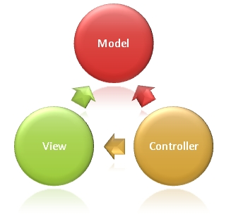

Figure 1: MVC implemented in a three-layer architecture

The above diagram is explained as the following:

**Model**: Used to prepare data for view

**View**: The view displays the data and also takes input form user. It renders the model data into a form, such as graphics, buttons, and tables, and so on to display to the user.

**Controller:** The controller handles all requests coming from the view or user interface. The data flows to whole application are controlled by controller.

#### Discussion of Alternative Designs

N/A

#### Description of System Interface

N/A

### Component Diagram

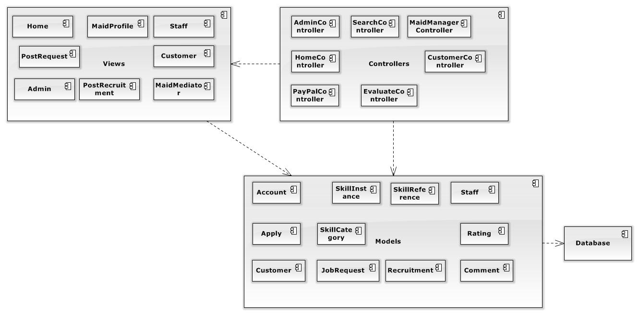

Figure 2: Component Diagram

### Detailed Description of Components

#### C:\Users\USER\Desktop\Main.jpgClass Diagram

Figure 3: General Class Diagram

#### Class Diagram Explanation

##### Account

* **Attributes**

|  |  |  |
| --- | --- | --- |
| **Name** | **Type** | **Description** |
| AccountId | Integer | Id of Account |
| Username | String | Username of user |
| Password | String | Password of user |
| IsActive | Boolean | Check account is active |
| JoinDate | Date | Date that user create an account |
| Role | String | Role of User |
| IsWebmaster | Boolean | Check account is an admin |
| Avatar | String | Image of user |
| Email | String | Email of user |
| Phone | String | Phone of user |
| FullName | String | Fullname of user |

* **Methods**

|  |  |  |  |
| --- | --- | --- | --- |
| **Name** | **Parameter** | **Return Type** | **Description** |
| Constructors | Optional | Account | Initialize a role with value (optional) |
| Getters | N/A | Type of attribute | Get value of an attribute corresponding with getter of attribute |
| Setters | Value of attribute | Void | Set value for an attribute corresponding with setter of attribute |
| Login | - Username  - Password | Void | Login to website |
| Register | All params of class Account | Account | Create an account |
| Signout | N/A | Boolean | Log out account |

##### Apply

* **Attributes**

|  |  |  |
| --- | --- | --- |
| **Name** | **Type** | **Description** |
| RecruitmentId | Integer | Id of recruitment |
| JobRequestId | Integer | Id of job request |

* **Methods**

|  |  |  |  |
| --- | --- | --- | --- |
| **Name** | **Parameter** | **Return Type** | **Description** |
| Constructors | Optional | Account | Initialize an account with value (optional) |
| Getters | N/A | Type of attribute | Get value of an attribute corresponding with getter of attribute |
| Setters | Value of attribute | Void | Set value for an attribute corresponding with setter of attribute |

##### Comment

* **Attributes**

|  |  |  |
| --- | --- | --- |
| **Name** | **Type** | **Description** |
| CommentId | Integer | Id of comment |
| CustomerId | Integer | Id of customer |
| JobRequestId | Integer | Id of job request |
| PostTime | Datetime | Time that comment was posted |
| CommentContent | String | Content of comment |

* **Methods**

|  |  |  |  |
| --- | --- | --- | --- |
| **Name** | **Parameter** | **Return Type** | **Description** |
| Constructors | Optional | Stadium | Initialize an Stadium with value (optional) |
| Getters | N/A | Type of attribute | Get value of an attribute corresponding with getter of attribute |
| Setters | Value of attribute | Void | Set value for an attribute corresponding with setter of attribute |
| AddComment | All attributes of class Comment | Boolean | Create a comment and save it to database |
| DeleteComment |  | Boolean | Delete a comment out of database |

##### Customer

* **Attributes**

|  |  |  |
| --- | --- | --- |
| **Name** | **Type** | **Description** |
| AccountId | Integer | Id of field |
| Payment | Float | Payment of customer |
| Address | String | Address of customer |

* **Methods**

|  |  |  |  |
| --- | --- | --- | --- |
| **Name** | **Parameter** | **Return Type** | **Description** |
| Constructors | Optional | Field | Initialize an Field with value (optional) |
| Getters | N/A | Type of attribute | Get value of an attribute corresponding with getter of attribute |
| Setters | Value of attribute | Void | Set value for an attribute corresponding with setter of attribute |
| PostRecruitment | - AccountId  - RecruitmentId | Boolean | Create and post a recruitment to website and save it to database |
| EditRecruitment | - AccountId  - RecruitmentId | Boolean | Edit a recruitment and save it to database |
| DeleteRecruitment | - AccountId | Boolean | Delete a recruitment out of database |
| EditProfile | All attributes of class Customer | Boolean | Edit profile of customer and save it to database |
| ApplyJobRequest | - AccountId  - JobRequestId | Boolean | Apply job request |

##### JobRequest

* **Attributes**

|  |  |  |
| --- | --- | --- |
| **Name** | **Type** | **Description** |
| JobRequestId | Integer | Id of job request |
| SkillRefId | Integer | Id of skill reference |
| MaidMediatorId | Integer | Id of maid mediator |
| StaffId | Integer | Id of staff |
| Status | String | Status of job request |
| PostTime | Datetime | Time that job request was post |
| ExpiredTime | Datetime | Time that job request was expired |
| ApplyTime | Datetime | Time that job request was applied |
| MaidId | Integer | Id of maid |
| IsActive | Boolean | Check that job request is active |

* **Methods**

|  |  |  |  |
| --- | --- | --- | --- |
| **Name** | **Parameter** | **Return Type** | **Description** |
| Constructors | Optional | FieldPrice | Initialize an FieldPrice with value (optional) |
| Getters | N/A | Type of attribute | Get value of an attribute corresponding with getter of attribute |
| Setters | Value of attribute | Void | Set value for an attribute corresponding with setter of attribute |
| Search | - SkillRefId  - searchString  - JobRequestId | List<SkillReference> | Search skill |
| Extend | - JobRequestId  - ExpiredTime | Boolean | Extend time to post job request |
| Rate | - SkillRefId  - JobRequestId  - MaidId | Integer | Rate the job request |

##### Maid

* **Attributes**

|  |  |  |
| --- | --- | --- |
| **Name** | **Type** | **Description** |
| MaidId | Integer | Id of maid |
| MaidName | String | Name of maid |
| MaidMediatorId | Integer | Id of maid mediator |
| StaffId | Integer | Id of staff |
| PersonalImage | String | Image of maid |
| Experience | Float | Experience of maid |
| Description | String | Description of maid |
| RateAvg | Float | Average rate of maid |
| Phone | String | Phone of maid |
| Gender | String | Gender of maid |

* **Methods**

|  |  |  |  |
| --- | --- | --- | --- |
| **Name** | **Parameter** | **Return Type** | **Description** |
| Constructors | Optional | PriceTable | Initialize an price table with value (optional) |
| Getters | N/A | Type of attribute | Get value of an attribute corresponding with getter of attribute |
| Setters | Value of attribute | Void | Set value for an attribute corresponding with setter of attribute |

##### MaidMediator

* **Attributes**

|  |  |  |
| --- | --- | --- |
| **Name** | **Type** | **Description** |
| AccountId | Integer | Id of maid mediator |
| Payment | Float | Payment of maid mediator |

* **Methods**

|  |  |  |  |
| --- | --- | --- | --- |
| **Name** | **Parameter** | **Return Type** | **Description** |
| Constructors | Optional | Promotion | Initialize an Promotion with value (optional) |
| Getters | N/A | Type of attribute | Get value of an attribute corresponding with getter of attribute |
| Setters | Value of attribute | Void | Set value for an attribute corresponding with setter of attribute |
| AddMaid | - AccountId  - All attributes of class maid | Boolean | Create a maid and save it to database |
| EditMaid | All attributes of class maid except MaidId | Boolean | Update information of an existing maid in database |
| EditProfile | All atrributes of class maidmediator | Boolean | Update information of an existing maid mediator in database |
| PostJobRequest | - SkillRefId  - MaidId  - MaidMediatorId  - JobRequestId  - PostTime | Boolean | Create and post a job request to website and save it to database |
| DeleteJobRequest | - SkillRefId  - MaidId  - MaidMediatorId  - JobRequestId | Boolean | Delete job request out of database |

##### Rating

* **Attributes**

|  |  |  |
| --- | --- | --- |
| **Name** | **Type** | **Description** |
| RatingId | Integer | Id of rating |
| CustomerId | Integer | Id of customer |
| JobRequestId | Integer | Id of job request |
| Rate | String | Rate |

* **Methods**

|  |  |  |  |
| --- | --- | --- | --- |
| **Name** | **Parameter** | **Return Type** | **Description** |
| Constructors | Optional | Promotion | Initialize an Promotion with value (optional) |
| Getters | N/A | Type of attribute | Get value of an attribute corresponding with getter of attribute |
| Setters | Value of attribute | Void | Set value for an attribute corresponding with setter of attribute |
| Rate | All attributes of class rating | Boolean | Rate job request |

##### Recruitment

* **Attributes**

|  |  |  |
| --- | --- | --- |
| **Name** | **Type** | **Description** |
| RecruitmentId | Integer | Id of recruitment |
| SkillRefId | Integer | Id of skill reference |
| CustomerId | Integer | Id of customer |
| Status | String | Status of recruitment |
| PostTime | Datetime | Time that recruitment was posted |
| ExpiredTime | Datetime | Time that recruitment was expired |

* **Methods**

|  |  |  |  |
| --- | --- | --- | --- |
| **Name** | **Parameter** | **Return Type** | **Description** |
| Constructors | Optional | Promotion | Initialize an Promotion with value (optional) |
| Getters | N/A | Type of attribute | Get value of an attribute corresponding with getter of attribute |
| Setters | Value of attribute | Void | Set value for an attribute corresponding with setter of attribute |
| Search | - SkillRefId  - searchString  - RecruitmentId | List<SkillReference> | Search skill |
| Extend | - RecruitmentId  - ExpiredTime | Boolean | Extend time to post recruitment |

##### SkillCategory

* **Attributes**

|  |  |  |
| --- | --- | --- |
| **Name** | **Type** | **Description** |
| CategoryId | Integer | Id of category |
| CategoryName | String | Name of category |

* **Methods**

|  |  |  |  |
| --- | --- | --- | --- |
| **Name** | **Parameter** | **Return Type** | **Description** |
| Constructors | Optional | StadiumRating | Initialize an StadiumRating with value (optional) |
| Getters | N/A | Type of attribute | Get value of an attribute corresponding with getter of attribute |
| Setters | Value of attribute | Void | Set value for an attribute corresponding with setter of attribute |

##### SkillInstance

* **Attributes**

|  |  |  |
| --- | --- | --- |
| **Name** | **Type** | **Description** |
| SkillId | Integer | Id of skill |
| CategoryId | Integer | Id of category |
| SkillName | String | Name of skill |
| SkillString | String | The charater value of skill |
| SkillNormallied | Int | The range value of skill |
| SkillStringValue | Float | The number value of skill name |
| SkillNameVietNam | String | The name of skill in Vietnamese |

* **Methods**

|  |  |  |  |
| --- | --- | --- | --- |
| **Name** | **Parameter** | **Return Type** | **Description** |
| Constructors | Optional | StadiumRating | Initialize an StadiumRating with value (optional) |
| Getters | N/A | Type of attribute | Get value of an attribute corresponding with getter of attribute |
| Setters | Value of attribute | Void | Set value for an attribute corresponding with setter of attribute |

##### SkillReference

* **Attributes**

|  |  |  |
| --- | --- | --- |
| **Name** | **Type** | **Description** |
| SkillRefId | Integer | Id of Skill reference |
| Gender | Integer | The value gender of skill |
| Age | Integer | The value age of skill |
| LaguageEnglish | Integer | The value language english of skill |
| LanguageChina | Integer | The value language china of skill |
| LanguageJapanese | Integer | The value language japanese of skill |
| LanguageKorean | Integer | The value language korean of skill |
| Experience | Integer | The value experience of skill |
| Hometown | Integer | The value hometown of skill |
| Address | Integer | The value address of skill |
| Health | Integer | The value health of skill |
| Stay | Integer | The value stay of skill |
| Salary | Integer | The value salary of skill |
| Work | Integer | The value work of skill |
| SickCare | Integer | The value sickcare of skill |
| OldCare | Integer | The value oldcare of skill |
| BabySister | Integer | The value babysister of skill |
| DisabilityCare | Integer | The value disabilitycare of skill |
| BonsaiCare | Integer | The value bonsaicare of skill |
| Cooking | Integer | The value cooking of skill |
| Washing | Integer | The value washing of skill |
| Cleanhouse | Integer | The value cleanhouse of skill |
| Type | Integer | Skill of job request or skill of recruitment |
| Group | Integer | Divide group in algorithm |

* **Methods**

|  |  |  |  |
| --- | --- | --- | --- |
| **Name** | **Parameter** | **Return Type** | **Description** |
| Constructors | Optional | Reservation | Initialize an Reservation with value (optional) |
| Getters | N/A | Type of attribute | Get value of an attribute corresponding with getter of attribute |
| Setters | Value of attribute | Void | Set value for an attribute corresponding with setter of attribute |

##### System

* **Methods**

|  |  |  |  |
| --- | --- | --- | --- |
| **Name** | **Parameter** | **Return Type** | **Description** |
| MatchGroup | All atributes of SkillReference | Integer | Match job request group with recruitment group |
| GetKmeanGroup | All atributes of SkillReferencr | Double [][] | Choose the best couple group to suggest |
| SendSMS | N/A | Boolean | Send SMS |

### Sequence Diagram

#### C:\Users\USER\Desktop\Login.jpgLogin

Figure 4: Login

#### C:\Users\USER\Desktop\AdvanceSearch.jpgAdvance Search

Figure 5: Advance Search

#### AddMaid

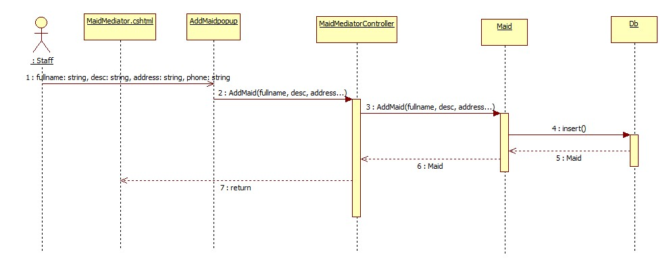

Figure 6: Add Maid

#### C:\Users\USER\Desktop\ManageMaidProfile.jpgManage Maid Profile

Figure 7: Manage Maid Profile

#### C:\Users\USER\Desktop\RemoveJob.jpgRemove Job

Figure 8: Remove Job

#### C:\Users\USER\Desktop\PostRequest.jpgPost Request

Figure 9: Post Request

#### C:\Users\USER\Desktop\AddRequest.jpgAdd Request

Figure 10: Add Request

#### C:\Users\USER\Desktop\RunKMean.jpgRun KMean

Figure 11: Run KMean

#### Register

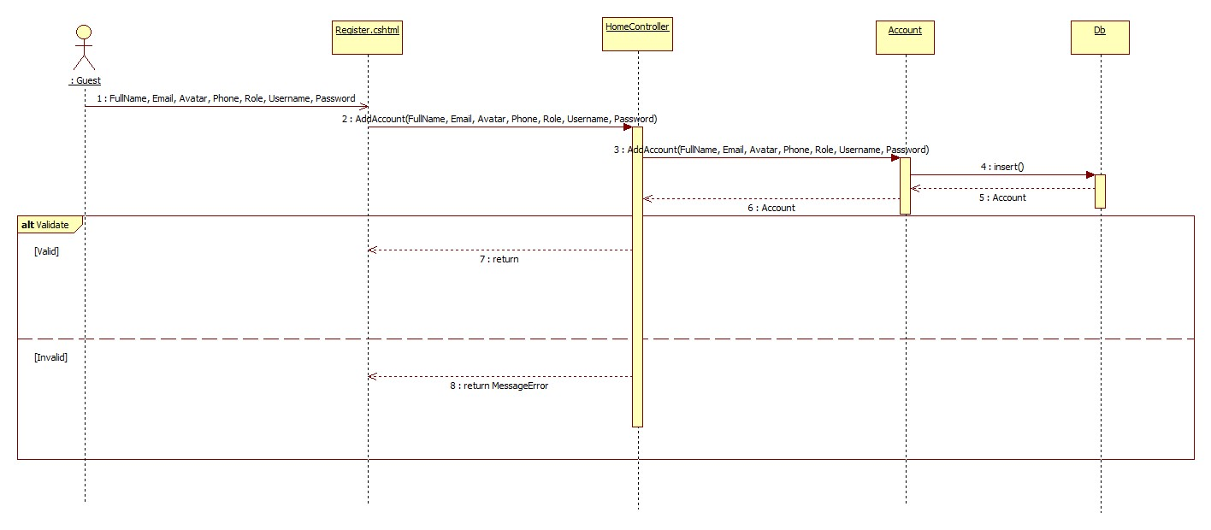Figure 12: Register

#### C:\Users\USER\Desktop\Search.jpgSearch

Figure 13: Search

### User Interface Design/ Hardware Interface Design (if any)

Update Later

### Database Design

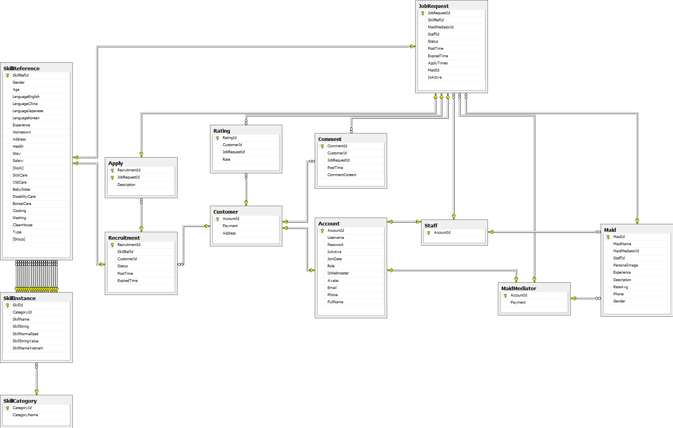

Figure 16: Database Diagram

#### Tables description

|  |  |  |
| --- | --- | --- |
| No. | Table name | Description |
| 1 | Account | Describe about users in system |
| 2 | Apply | Describe Apply |
| 3 | Comment | Describe all comment |
| 5 | Customer | Describe all customers informations |
| 6 | JobRequest | Describe all job requests |
| 5 | MaidMediator | Describe all maid mediators information |
| 7 | Maid | Describe all maids information |
| 8 | Rating | Describe all rating |
| 9 | Recruitment | Describe all recruitments |
| 10 | SkillCategory | Describe all SkillCategory |
| 11 | SkillIntance | Describe all SkillIntance |
| 12 | SkillReference | Describe all SkillReference |
| 13 | Staff | Describe all staffs information |

#### Acount

|  |  |  |  |  |  |  |
| --- | --- | --- | --- | --- | --- | --- |
| Field name | Type | Null | Unique | P/F key | Default | Description |
| AccountId | int |  |  | PK |  | The index of this account |
| Username | nvarchar(50) |  |  |  |  | The username of the account |
| Password | nvarchar(50) |  |  |  |  | The password of the password |
| IsActive | bit |  |  |  |  | Admin can ban account |
| JoinDate | date |  |  |  |  | The date when this user join |
| Role | nvarchar(50) |  |  |  |  | The role of the user |
| IsWebmaster | bit |  |  |  |  | Check acount is admin |
| Avatar | nvarchar(50) | Yes |  |  |  | The link refers to an image, present for a user |
| Email | nvarchar(50) | Yes |  |  |  | The email of user |
| Phone | nvarchar(50) | Yes |  |  |  | Phone of user |
| Fullname | nvarchar(50) | Yes |  |  |  | The fullname of user |

#### Apply

|  |  |  |  |  |  |  |
| --- | --- | --- | --- | --- | --- | --- |
| Field name | Type | Null | Unique | P/F key | Default | Description |
| RecruitmentId | int |  |  | PK |  | The index of this recruitment |
| JobRequestId | Int |  |  | PK |  | The index of this job request |
| Description | nvarchar(50) |  |  |  |  | N/A |

#### Comment

|  |  |  |  |  |  |  |
| --- | --- | --- | --- | --- | --- | --- |
| Field name | Type | Null | Unique | P/F key | Default | Description |
| CommentId | int |  |  | PK |  | The index of this comment |
| CustomerId | int |  |  | FK |  | The index of customer which contain this comment |
| JobRequestId | int |  |  | FK |  | The index of job request which is contain this comment |
| PostTime | datetime |  |  |  |  | The time when the comment posted |
| CommentContent | nvarchar(500) |  |  |  |  | The content of the comment |

#### Customer

|  |  |  |  |  |  |  |
| --- | --- | --- | --- | --- | --- | --- |
| Field name | Type | Null | Unique | P/F key | Default | Description |
| AccountId | int |  |  | PK |  | The index of user |
| Payment | float |  |  |  |  | The payment of customer |
| Address | nvarchar(100) |  |  |  |  | The address of customer |

#### JobRequest

|  |  |  |  |  |  |  |
| --- | --- | --- | --- | --- | --- | --- |
| Field name | Type | Null | Unique | P/F key | Default | Description |
| JobRequestId | int |  |  | PK |  | The index of this job request |
| SkillRefId | int |  |  | FK |  | The SkillRef of this job request |
| MaidMediatorId | int | Yes |  | FK |  | The maid mediator of this job request |
| StaffId | Int | Yes |  | FK |  | The staff of this job request |
| Status | nvarchar(50) |  |  |  |  | The status of this job request |
| PostTime | datetime |  |  |  |  | The time that this job request is posted |
| ExpiredTime | datetime |  |  |  |  | The time that this job request is expired |
| ApplyTimes | datetime |  |  |  |  | The time that this job request is applied |
| MaidId | int |  |  | FK |  | The maid of this job request |
| IsActive | bit |  |  |  |  | Check that this job request has payment |

#### Maid

|  |  |  |  |  |  |  |
| --- | --- | --- | --- | --- | --- | --- |
| Field name | Type | Null | Unique | P/F key | Default | Description |
| MaidId | int |  |  | PK |  | The index of maid |
| MaidName | nvarchar(50) |  |  |  |  | The name of maid |
| MaidMediator | int |  |  | FK |  | The maid mediator of maid |
| StaffId | Int |  |  | FK |  | The staff mediator of maid |
| PersonalImage | nvarchar(50) |  |  |  |  | The image of maid |
| Experience | float |  |  |  |  | The years experience of maid |
| Description | nvarchar(500) |  |  |  |  | The description of maid |
| RateAvg | float |  |  |  |  | The average rating of maid |
| Phone | nvarchar(50) |  |  |  |  | The phone of maid |
| Gender | nvarchar(10) |  |  |  |  | The gender of maid |

#### MaidMediator

|  |  |  |  |  |  |  |
| --- | --- | --- | --- | --- | --- | --- |
| Field name | Type | Null | Unique | P/F key | Default | Description |
| AccountId | int |  |  | PK |  | The index of this maid mediator |
| Payment | int |  |  |  |  | The payment of the maid mediator |

#### Rating

|  |  |  |  |  |  |  |
| --- | --- | --- | --- | --- | --- | --- |
| Field name | Type | Null | Unique | P/F key | Default | Description |
| RatingId | int |  |  | PK |  | The index of this rating |
| CustomerId | int |  |  | FK |  | The customer who rate |
| JobRequestId | int |  |  | FK |  | The job request which is rated |
| Rate | float |  |  |  |  | The value of this rate |

#### Recruitment

|  |  |  |  |  |  |  |
| --- | --- | --- | --- | --- | --- | --- |
| Field name | Type | Null | Unique | P/F key | Default | Description |
| RecruitmentId | int |  |  | PK |  | The index of this recruitment |
| SkillRefId | int |  |  | FK |  | The index of skill which contains in this recruitment |
| CustomerId | int |  |  | FK |  | The customer who posts this recruitment |
| Status | nvarchar(50) |  |  |  |  | The status of the recruitment |
| PostTime | datetime |  |  |  |  | The time when the recruitment is posted |
| ExpiredTime | datetime |  |  |  |  | The time when the recruitment is expired |

#### SkillCategory

|  |  |  |  |  |  |  |
| --- | --- | --- | --- | --- | --- | --- |
| Field name | Type | Null | Unique | P/F key | Default | Description |
| CategoryId | int |  |  | PK |  | The index of this category |
| CategoryName | nvarchar(50) |  |  |  |  | The name of category |

#### SkillInstance

|  |  |  |  |  |  |  |
| --- | --- | --- | --- | --- | --- | --- |
| Field name | Type | Null | Unique | P/F key | Default | Description |
| SkillId | int |  |  | PK |  | The index of this skill |
| CategoryId | int |  |  | FK |  | The category which contains this skill |
| SkillName | nvarchar(50) |  |  |  |  | The name of skill |
| SkillString | nvarchar(50) | Yes |  |  |  | The character value of skill name |
| SkillNormallized | int |  |  |  |  | The range value of skill |
| SkillStringValue | float |  |  |  |  | The number value of skill name |
| SkillNameVietnam | nvarchar(50) |  |  |  |  | The name of skill in Vietnamese |

#### SkillReference

|  |  |  |  |  |  |  |
| --- | --- | --- | --- | --- | --- | --- |
| Field name | Type | Null | Unique | P/F key | Default | Description |
| SkillRefId | int |  |  | PK |  | The index of this skill reference |
| Gender | int | Yes |  |  |  | The value gender of skill |
| Age | int | Yes |  |  |  | The value age of skill |
| LaguageEnglish | int | Yes |  |  |  | The value language english of skill |
| LanguageChina | int | Yes |  |  |  | The value language china of skill |
| LanguageJapanese | int | Yes |  |  |  | The value language japanese of skill |
| LanguageKorean | int | Yes |  |  |  | The value language korean of skill |
| Experience | int | Yes |  |  |  | The value experience of skill |
| Hometown | int | Yes |  |  |  | The value hometown of skill |
| Address | int | Yes |  |  |  | The value address of skill |
| Health | int | Yes |  |  |  | The value health of skill |
| Stay | int | Yes |  |  |  | The value stay of skill |
| Salary | int | Yes |  |  |  | The value salary of skill |
| Work | int | Yes |  |  |  | The value work of skill |
| SickCare | int | Yes |  |  |  | The value sickcare of skill |
| OldCare | int | Yes |  |  |  | The value oldcare of skill |
| BabySister | int | Yes |  |  |  | The value babysister of skill |
| DisabilityCare | int | Yes |  |  |  | The value disabilitycare of skill |
| BonsaiCare | int | Yes |  |  |  | The value bonsaicare of skill |
| Cooking | int | Yes |  |  |  | The value cooking of skill |
| Washing | int | Yes |  |  |  | The value washing of skill |
| Cleanhouse | int | Yes |  |  |  | The value cleanhouse of skill |
| Type | int |  |  |  |  | Skill of job request or skill of recruitment |
| Group | int | Yes |  |  |  | Divide group in algorithm |

#### Staff

|  |  |  |  |  |  |  |  |  |  |  |  |  |
| --- | --- | --- | --- | --- | --- | --- | --- | --- | --- | --- | --- | --- |
| Field name | Type | | Null | | Unique | | P/F key | | Default | | Description | |
| AccountId | | int | |  | |  | | PK | |  | | The index of this staff |

### Business Intelligence Agent: Suggestion Method

#### Overview:

This is automatically function, help system classify each job request and recruitment from maid and customer. Function give all request become n-group. From there, system can be suggest for user about:

* Job requests same Recruitment

#### Implement:

**K-Mean**

* Web master feel need create new group for Job request and recruitment. Because each group should have maximum 10 element.
* When web master click run classify, all job request and recruitment has been calculate by algorithm, and make new group.
* New group based on similar of value from column Normalize of data.
* A file contain k mean, with k is number of group. This file will be save on server of website.
* After run algorithm, in database, all job request and recruitment is “Watting” status will be classify k group.

**KNN**

* User login with customer role.
* They post a recruitment on website.
* System automatic analysis and choose group for this recruitment.
* From there, system can suggest for customer all job request same group with this recruitment.

#### Algorithm

K-Mean

* Normalize value. This step help return value same distant.
* Random group for value.
* Choose a number k. In MS-Website, system suggest each group at job request and recruitment should have 10 element. Therefore, if job request have 100 rows we should choose k equal 10. Choose random k mean.
* Calculate the distance between the objects (objects) to K center (usually Euclidean distance).
* Group objects to the nearest group.
* Define the new mean for the group.
* Repeat until no change in any group of objects.
* Write mean to file and save this file in sever.

KNN

* Witch input value, calculate distance from this to k mean of mean file on sever.
* Find minimum distance form this point to means. This value will belong minimum mean group.

Figure 17 K-Mean algorithm

Start

Number of

cluster K

Centroid

Distance object to centroids

Grouping based on minimum distance

No object move group?

End